THOSE PESKY TICKS!

Symptoms of tick bites  Tick bites aren’t usually painful, but they may cause a red lump to develop where you were bitten. In some cases, tick bites may cause:  - Swelling  - Itchiness  - Blistering  - Bruising  Ticks in England can carry infections, including Lyme disease and, very rarely, tick-borne encephalitis (TBE). Ticks can be active all year round, but they are most active in the months April to July, and sometimes later in the autumn. Activity does continue over the winter months but at a significantly reduced level. | 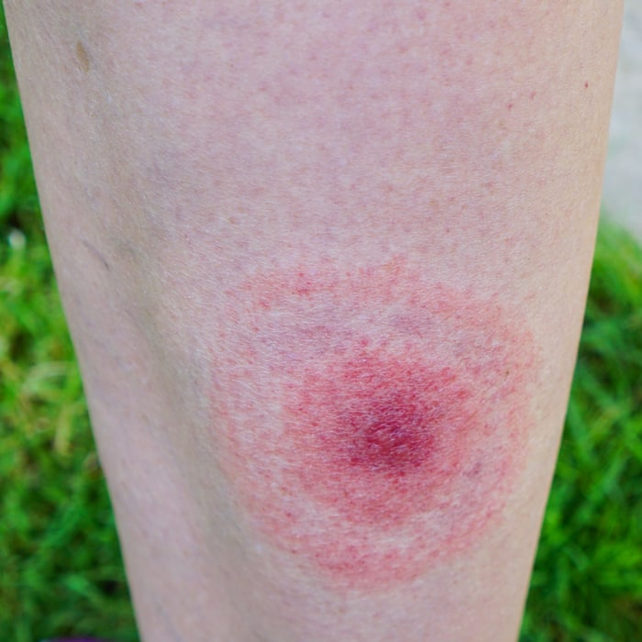
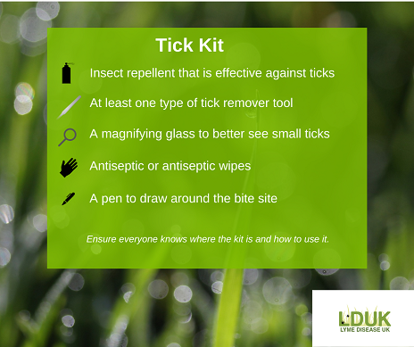 | Preventing tick bites  - Keep to footpaths and avoid long grass when out walking  - Wear appropriate clothing (long-sleeved shirt and trousers tucked into your socks)  - Wear light-coloured fabrics that may help you spot a tick on your clothes  - Use insect repellent on exposed skin  - Check your skin for ticks  - Check your children’s skin for ticks, especially the head and neck areas, including their scalp  - Make sure ticks are not brought home on your clothes  - Check that pets do not bring ticks into your home in their fur
How to remove ticks  If you’ve been bitten by a tick, it will attach to your skin. You should try to remove it as soon as possible. This helps to reduce the risk of getting a tick-borne infection, like Lyme disease. You should:  - Use a tick removal device or fine-toothed tweezers to gently grip the tick as close to the skin as possible.  - Pull steadily away from the skin without crushing the tick.  - Wash your skin with water and soap afterwards.  - Apply an antiseptic cream to the skin around the bite. | 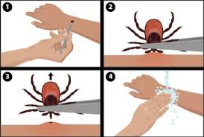
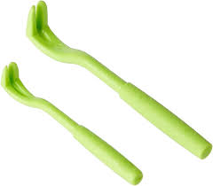 | Many pharmacies and outdoor stores sell tick removal devices. These are useful if you often spend time in areas where there are ticks. If the tick’s mouthparts break off in the skin and cannot be removed, this may cause irritation. However, they should fall out naturally in time.

